Purpose: Day 14 Classwork and Assignment
Date: 09/01/2026
Author: Vinayak Majhi
ID: 58618
Batch ID: 25SUB4505 - DATACOM+5G

ClassWork

Q.1. Sum of Numbers.

Create a shared variable sum, where you have 3 threads adding 1 to 1000 to sum variable.

Focus: on correct placement of mutex lock

a. lock_guard

b. Unique_lock

- Lock_guard

// Purpose: Sum numbers from 1 to 1000 using multiple threads (lock_guard)
// Date: 09/01/2026
// Author: Vinayak Majhi
// ID: 58618
// Batch ID: 25SUB4505 - DATACOM+5G

#include <iostream>
#include <mutex>
#include <thread>
using namespace std;

long long sum = 0;
mutex m;

void addRange(int start, int end) {
for (int i = start; i <= end; i++) {
lock_guard<mutex> lg(m);
sum += i;
}
}

int main() {
thread t1(addRange, 1, 333);
thread t2(addRange, 334, 666);
thread t3(addRange, 667, 1000);

t1.join();
t2.join();
t3.join();

cout << "Final Sum = " << sum << endl;
return 0;
}

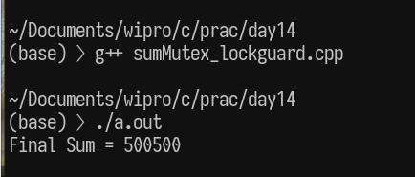

- Unique_lock

// Purpose: Sum numbers from 1 to 1000 using multiple threads (unique_lock)
// Date: 09/01/2026
// Author: Vinayak Majhi
// ID: 58618
// Batch ID: 25SUB4505 - DATACOM+5G

#include <iostream>
#include <mutex>
#include <thread>
using namespace std;

long long sum = 0;
mutex m;

void addRange(int start, int end) {
for (int i = start; i <= end; i++) {
unique_lock<mutex> ul(m);
sum += i;
}
}

int main() {
thread t1(addRange, 1, 333);
thread t2(addRange, 334, 666);
thread t3(addRange, 667, 1000);

t1.join();
t2.join();
t3.join();

cout << "Final Sum = " << sum << endl;
return 0;
}

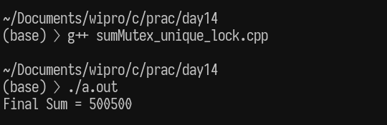

Q 2. Printing series of values:

Create 3 threads which will

print numbers from 1 - 10

output should be like given below

Output:

Thread #1: 1 2 3 4 5 6 7 8 9 10

Thread #2: 1 2 3 4 5 6 7 8 9 10

Thread #3: 1 2 3 4 5 6 7 8 9 10

// Purpose: Print 1–10 using 3 threads with IO synchronization
// Date: 09/01/2026
// Author: Vinayak Majhi
// ID: 58618
// Batch ID: 25SUB4505 - DATACOM+5G

#include <iostream>
#include <mutex>
#include <thread>
using namespace std;

mutex ioMutex;

void printSeries(int id) {
lock_guard<mutex> lg(ioMutex);
cout << "Thread #" << id << ": ";
for (int i = 1; i <= 10; i++)
cout << i << " ";
cout << endl;
}

int main() {
thread t1(printSeries, 1);
thread t2(printSeries, 2);
thread t3(printSeries, 3);

t1.join();
t2.join();
t3.join();
return 0;
}

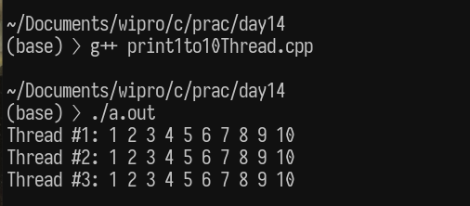

Q 3. Bank Account Simulation

Create a BankAccount class with:

balance (shared)

deposit(int)

withdraw(int)

Task

Run deposit and withdraw operations from multiple threads

Protect the balance using a mutex

Focus

Mutex inside a class

Thread-safe methods

// Purpose: Bank account simulation with thread-safe methods
// Date: 09/01/2026
// Author: Vinayak Majhi
// ID: 58618
// Batch ID: 25SUB4505 - DATACOM+5G

#include <iostream>
#include <mutex>
#include <thread>
using namespace std;

class BankAccount {
int balance;
mutex m;

public:
BankAccount(int bal) : balance(bal) {}

void deposit(int amt) {
lock_guard<mutex> lg(m);
balance += amt;
}

void withdraw(int amt) {
lock_guard<mutex> lg(m);
if (balance >= amt)
balance -= amt;
}

int getBalance() { return balance; }
};

int main() {
BankAccount acc(1000);

thread t1(&BankAccount::deposit, &acc, 500);
thread t2(&BankAccount::withdraw, &acc, 300);
thread t3(&BankAccount::deposit, &acc, 200);

t1.join();
t2.join();
t3.join();

cout << "Final Balance = " << acc.getBalance() << endl;
return 0;
}

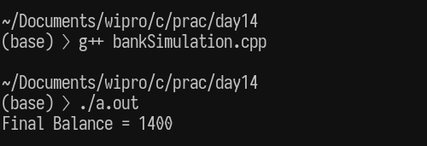

Q.4 Deadlock Scenario (Analysis)

Create two mutexes m1 and m2.

Task

Thread A locks m1 then m2

Thread B locks m2 then m1

Questions

What happens?

Why is this dangerous?

Focus

Deadlock understanding

Fixing the above problem:

Locking mutexes in a consistent order

OR

Using std::lock(m1, m2)

deadLock_eg.cpp
// Purpose: Demonstrate Deadlock Scenario
// Date: 09/01/2026
// Author: Vinayak Majhi
// ID: 58618
// Batch ID: 25SUB4505 - DATACOM+5G

#include <chrono>
#include <iostream>
#include <mutex>
#include <thread>

using namespace std;

mutex m1, m2;

void threadA() {
m1.lock();
cout << "Thread A locked m1\n";
this_thread::sleep_for(chrono::milliseconds(100));

m2.lock(); // waits forever
cout << "Thread A locked m2\n";

m2.unlock();
m1.unlock();
}

void threadB() {
m2.lock();
cout << "Thread B locked m2\n";
this_thread::sleep_for(chrono::milliseconds(100));

m1.lock(); // waits forever
cout << "Thread B locked m1\n";

m1.unlock();
m2.unlock();
}

int main() {
thread t1(threadA);
thread t2(threadB);

t1.join();
t2.join();

return 0;
}

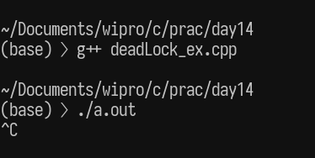
Result:
Program hangs
No further output
Deadlock confirmed

FIX using std::lock

// Purpose: Deadlock Fix using std::lock
// Date: 09/01/2026
// Author: Vinayak Majhi
// ID: 58618
// Batch ID: 25SUB4505 - DATACOM+5G

#include <iostream>
#include <mutex>
#include <thread>

using namespace std;

mutex m1, m2;

void safeFunction() {
lock(m1, m2); // deadlock-free locking
lock_guard<mutex> lock1(m1, adopt_lock);
lock_guard<mutex> lock2(m2, adopt_lock);

cout << "Thread safely locked both mutexes\n";
}

int main() {
thread t1(safeFunction);
thread t2(safeFunction);

t1.join();
t2.join();
return 0;
}

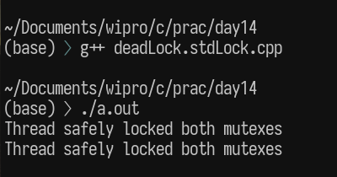

Q.5 Shared Resource Access Control

Create:

One shared resource

5 reader threads

2 writer threads

Task

Allow only one writer at a time

Readers must wait while writing

// Purpose: Shared resource access with readers and writers
// Date: 09/01/2026
// Author: Vinayak Majhi
// ID: 58618
// Batch ID: 25SUB4505 - DATACOM+5G

#include <iostream>
#include <mutex>
#include <thread>
using namespace std;

mutex resourceMutex;

void reader(int id) {
lock_guard<mutex> lg(resourceMutex);
cout << "Reader " << id << " is reading" << endl;
}

void writer(int id) {
lock_guard<mutex> lg(resourceMutex);
cout << "Writer " << id << " is writing" << endl;
}

int main() {
thread r1(reader, 1), r2(reader, 2), r3(reader, 3), r4(reader, 4),
r5(reader, 5);
thread w1(writer, 1), w2(writer, 2);

r1.join();
r2.join();
r3.join();
r4.join();
r5.join();
w1.join();
w2.join();
return 0;
}

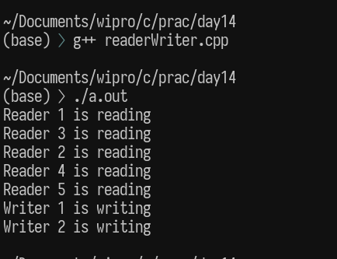
Q. 6. Write a C program, with 4 functions (fun(), funOne(), funTwo(), funThree()) called from main().

Have the prototypes in fun.h

definitions in respective files ((fun() --> fun.c), (funOne() --> funOne.c), (funTwo() --> funTwo.c), (funThree() --> funThree.c), (funFour() --> funFour.c))

(main() --> testMain.c) -->

Create

Static library myLib.a

compile your program with myLib.a

run and test the output

Debug the code using gdb

Dynamic library libMine.so

compile your program with libMine.so

run and test the output

Debug the code using gdb

Header File — fun.h

#ifndef FUN_H
#define FUN_H

void fun();
void funOne();
void funTwo();
void funThree();

#endif

Function Definitions (fun.c)

#include <stdio.h>
#include "fun.h"

void fun() {
printf("fun() called\n");
}

funOne.c

#include <stdio.h>
#include "fun.h"

void funOne() {
printf("funOne() called\n");
}

funTwo.c

#include <stdio.h>
#include "fun.h"

void funTwo() {
printf("funTwo() called\n");
}

funThree.c

#include <stdio.h>
#include "fun.h"

void funThree() {
printf("funThree() called\n");
}

Main Program — testMain.c

#include <stdio.h>
#include "fun.h"

int main() {
fun();
funOne();
funTwo();
funThree();
return 0;
}

PART A — Static Library (myLib.a)

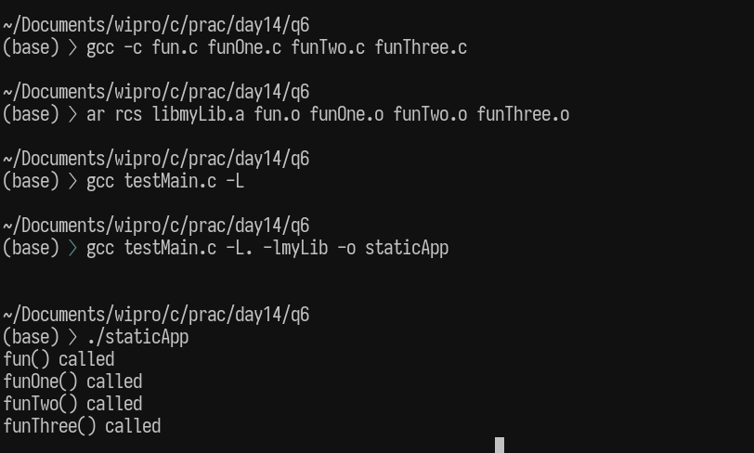

PART B — Dynamic Library (libMine.so)

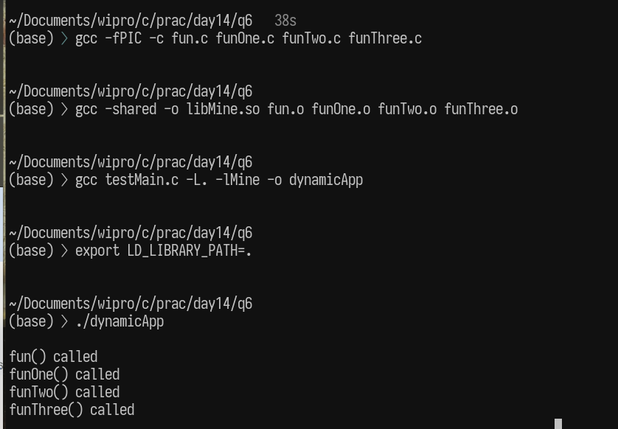

Q.7 Write a C++ program, with a Class Test with 4 functions (fun(), funOne(), funTwo(), funThree()) called from main().

Have the prototypes in fun.h

definitions in respective files ((fun() --> fun.cpp), (funOne() --> funOne.cpp), (funTwo() --> funTwo.cpp), (funThree() --> funThree.cpp), (funFour() --> funFour.cpp))

(main() --> testMain.cpp) -->

Create

Static library myLib.a

compile your program with myLib.a

run and test the output

Dynamic library libMine.so

compile your program with libMine.so

run and test the output

Debug the code using gdb

Header File — fun.h

#ifndef FUN_H
#define FUN_H

class Test {
public:
void fun();
void funOne();
void funTwo();
void funThree();
};

#endif

Function Definitions

fun.cpp

#include <iostream>
#include "fun.h"
using namespace std;

void Test::fun() {
cout << "fun() called" << endl;
}

funOne.cpp

#include <iostream>
#include "fun.h"
using namespace std;

void Test::funOne() {
cout << "funOne() called" << endl;
}

funTwo.cpp

#include <iostream>
#include "fun.h"
using namespace std;

void Test::funTwo() {
cout << "funTwo() called" << endl;
}
funThree.cpp

#include <iostream>
#include "fun.h"
using namespace std;

void Test::funThree() {
cout << "funThree() called" << endl;
}

Main Program — testMain.cpp

PART A — Static Library (myLib.a)

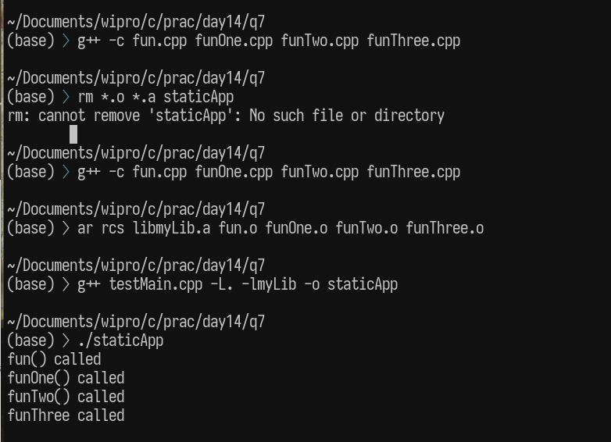

PART-2: Dynamic Library (libMine.so)

